# 法定代表人证明材料

## 2.1法定代表人身份证





## 2.2法定代表人任职文件

特别说明：应为加盖公章的正式公文。

## 2.3法定代表人职称证

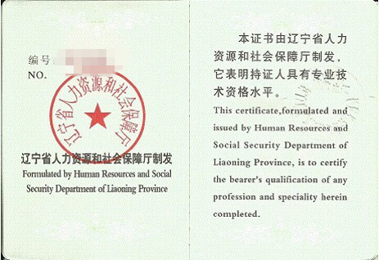

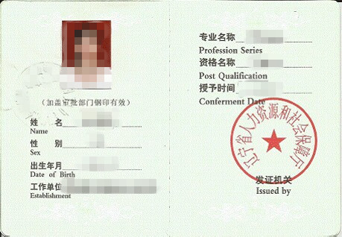

**说明：证件扫描件，等尺寸。**

## 毕业证1_副本_副本_副本2.4法定代表人毕业证

**说明：证件扫描件，尺寸可适当缩小。**

## 2.5法定代表人注册证

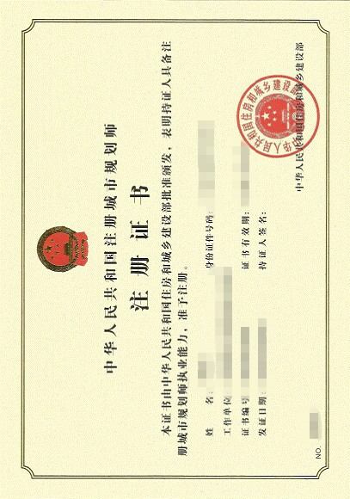

**说明：证件扫描件，尺寸可适当缩小。**

# 技术负责人简历

|  |  |  |  |  |  |  |  |  |  |  |  |  |  |  |  |  |  |  |  |  |  |  |  |
| --- | --- | --- | --- | --- | --- | --- | --- | --- | --- | --- | --- | --- | --- | --- | --- | --- | --- | --- | --- | --- | --- | --- | --- |
| 姓 名 |  | | | 性 别 | | | |  | | | | 出生年月 | | | |  | | | | 一寸正面  半身免冠  彩色相片 | | | |
| 现 从 事  专 业 |  | | | 参加工  作时间 | | | |  | | | | 职 务 | | | |  | | | |
| 最高学历 | 毕业院校、专业、时间 | | | | | | | | | | | | | | | 学位 | | | |
|  |  | | | | | | | | | | | | | | |  | | | |
| 专业技术  职称及  获得时间 |  | | | | | | | | | | | 从事城乡规划编制工作年限 | | | |  | | | | | | | |
| 注册资格类别等级及  获得时间 |  | | | | | | | | | | | 执 业  印 章 号 | | | |  | | | | | | | |
| 身份证  号 码 |  |  |  | |  |  |  | |  |  |  | |  |  |  | |  |  |  | |  |  |  |
| 从 事  技 术  工 作  经 历 |  | | | | | | | | | | | | | | | | | | | | | | |
| 主 要  专 业  技 术  工 作  业 绩 | 项目名称 | | | | | | | | 规划面积（万㎡） | | | | | | | | 完成时间 | | | | | | |
|  | | | | | | | |  | | | | | | | |  | | | | | | |
|  | | | | | | | |  | | | | | | | |  | | | | | | |
|  | | | | | | | |  | | | | | | | |  | | | | | | |
|  | | | | | | | |  | | | | | | | |  | | | | | | |
|  | | | | | | | |  | | | | | | | |  | | | | | | |
|  | | | | | | | |  | | | | | | | |  | | | | | | |

附：主要技术负责人任职文件

## 技术负责人任职文件

特别说明：应为加盖公章的正式公文。

**说明：文件扫描件，尺寸可适当缩小。**